

Asset Practice Answers: Science

**1. Which of these parts helps the plant to take in water?**

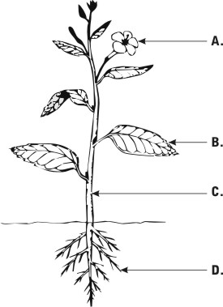 **Right Answer D**

**2. Where are you most likely to find the symbol shown below?**



**A.** On a television

**B.** On a pencil box

**C. On a medicine box**

**D.** On a chocolate box

**3. When we touch a hot pan with our hands we sense it is hot and drop it. Which of these organs helps us sense that the pan is hot?**

**A. Skin** **B.** Eyes **C.** Ears **D.** Nose

**4. Prabhu is a poor man living in a village that has no supply of clean drinking water. The only source of water in his village is a small pond of water which has dirt and germs in it. What should he do to make the water safe for drinking?**

**A.** Just filter the water using a cloth.

**B. Boil the water completely and filter it.**

**C.** Add common salt to the water.

**D.** Soak some neem leaves in the water.

**5. Which of these will help us keep our surroundings clean?**

**A.** Walking on footpaths

**B.** Watering the plants daily

**C. Throwing waste in dustbins**

**D.** Removing the petals of a flower

**6. Which of these is got from animals?**

**A.** Coffee **B.** Rubber **C.** Cotton **D. Wool**

**7. Rohini saw an animal that had two legs and feathers. Which animal did she see?**

**A.** Spider

**B.** Caterpillar

**C. Pigeon**

**D.** Horse

**8. Which of these can be eaten raw?**

**A.** Potatoes

**B.** Brinjal

**C. Tomatoes**

**D.** Beans

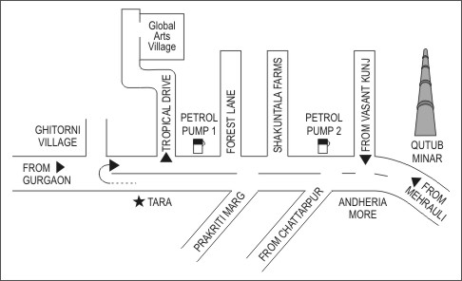**9.**

**Ayesha is travelling from TARA to Qutub Minar. Which of these will she find to her right?**

**A.** Global Arts Village

**B.** Ghitorni village

**C. Andheria More**

**D.** Qutub Minar

**10. In the figure, which of these would fit in place of the question mark?**

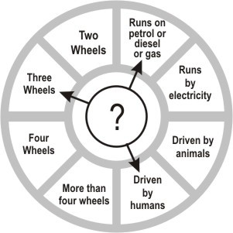

**A. Auto rickshaw** **B.** Cycle rickshaw **C.** Car

**D.** Truck

**11. Arjun: *Does the plant live for more than a year?***

**Ram: *Yes, it does.***

**Arjun: *Does the plant give us shade?***

**Ram: *Yes, it does.***

**Arjun: *Can we see its roots?***

**Ram: *No, we cannot.***

**Arjun: *Does the plant give us sweet fruits?***

**Ram: *Yes, it does.***

**Which plant is Ram describing?**

**A.** Rose

**B.** Coriander

**C. Mango**

**D.** Banyan

**12. From which of these places** will we **be able to clearly see the largest number of stars in the night sky?**

**A.** A well-lit main road of a city.

**B. A dark field away from the city.**

**C.** A cricket stadium when a match is going on.

**D.** The terrace of a building which has many lamps.



.

**Science**

1. D: Plants take in water from the soil using their roots. The part marked D in the figure shows the roots of the plant. Option

C shows the stem of the plant. The stem of the plant does not take in water from the soil. Hence, option C is incorrect.

2. C: The symbol of a cross usually shows something to do with medicine and health-care. It is not likely to be seen on a T.V. set, a pencil box or a chocolate box. Have you seen a first-aid box or a box in which medicines are kept? Such boxes will have this symbol to show that it is a medicine box or a first-aid box. Hence, option C is correct.

3. A: If there is a very hot steel plate, will you always be able to see that it is hot? You will not be able to see it or smell it or even hear it. The only way that you can find out whether the plate is hot is when you touch it. Your skin helps you find out whether something is hot or cold, rough or smooth, etc. Thus, option A is the only correct answer.

4. B: If you want to make water safe for drinking, you should first boil it to kill all the germs in it. Then, you should filter it to remove the dirt and dust from it. When we do this, the water becomes safe to drink. Only filtering the water or adding salt is not enough. Neem leaves are good for us, but they cannot clean dirty water and make it safe to drink. Hence, options A, C and D are incorrect.

5. C: Walking on footpaths or removing the petals of a flower does not help to keep our surroundings clean. Watering plants daily only helps plants grow - it does not help to clean up our surroundings, unless we grow many plants and make sure that we do not cut many trees down. When we throw waste in dustbins, it helps us keep our surroundings clean. Thus, option C is the only correct answer.

6. D: We get coffee, rubber and cotton from plants. Coffee is the seed of the coffee fruit. Rubber is made of a juice that comes out of the rubber plant. Cotton is made from the fruit of the cotton plant. We get wool from animals like sheep, goats, camels, etc. Hence, only option D is the correct answer.

7. C: Spiders, caterpillars and horses do not have feathers. The only animal that has two legs and feathers among the options is a pigeon. Hence, option C is the only correct answer.

8. C: Potatoes, brinjals and beans are usually not eaten raw. They are usually cooked. Tomatoes are found in many salads and can easily be eaten raw. Thus, option C is the correct answer.

9. C: Check where TARA and Qutub Minar are in the map. Imagine you are going from TARA to Qutub Minar. You will find Andheria More to your right on the way. Another way to check is to rotate the map to the left so that Qutub Minar is to the top and Tara is at the bottom. The road is going up. You will clearly see Andheria More to the right. Qutub Minar is the final place where Ayesha is going and it is straight down the road. It won't come to the right.

10. A: As we can see, the question mark is pointing to 3 different things - 1) it runs on petrol or diesel or gas, 2) it has three wheels and 3) it is driven by humans. The only vehicle that follows all these 3 points is an auto rickshaw. Though a car runs on petrol or diesel, it has four wheels and so it cannot be the answer. A cycle rickshaw is driven by humans but it does not run on petrol or diesel and so it cannot be the answer.

11. C: Have you read the questions and the answers correctly? Ram is describing a plant that lives for more than a year, gives us shade as well as sweet fruits. Since it gives us shade, it is a tree and cannot be a rose plant or a coriander plant. It is also given that we cannot see its roots. We can see some roots of banyan tree and so it cannot be the answer. The plant Ram is describing about is Mango.

12. B: Go to your terrace at night and see how many stars you can see clearly. Now go to the nearest crossroad with your parent and see how many stars you can see clearly. You will find that you can see stars clearly from a darker place. Of the given places, the best place to see too many stars would be a dark field away from the city. Any place which is dark and does not have many lights will be a good place to be at to see stars.